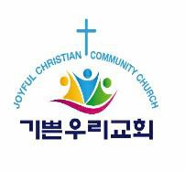

2024 JCCC Scholarship Award Timeline

Date | Schedule
April 15, 2024 | Announcement of scholarship application
May 31, 2024 | Application deadline
Week of July 22, 2024 | Announcement of scholarship award recipients
Early August 2024 | A scholarship award ceremony will be held during worship service at JCCC. The exact date will be posted on the JCCC website, www.joyfulccc.org

